Login to your tennis account ( created last year) via Tennis Australia website www.tennis.com.au
- Go to your profile
- Go to Memberships (LHS menu-3rd down)
- Click “Find a Court” – blue box – top RHS
- Under “Where do you want to play” Type in Littlehampton. Then click on
“Littlehampton SA 5250” then “search”
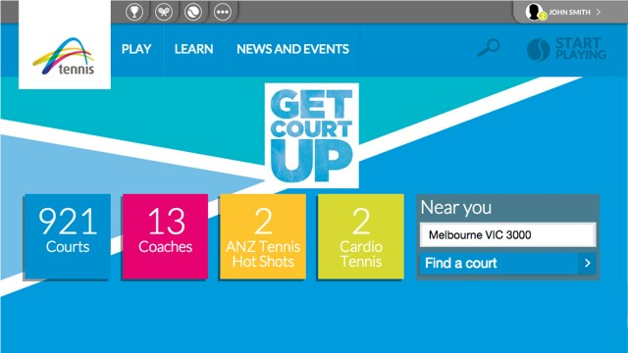
- Scroll down the page until you see Littlehampton Tennis Club
- Click “Join this club”
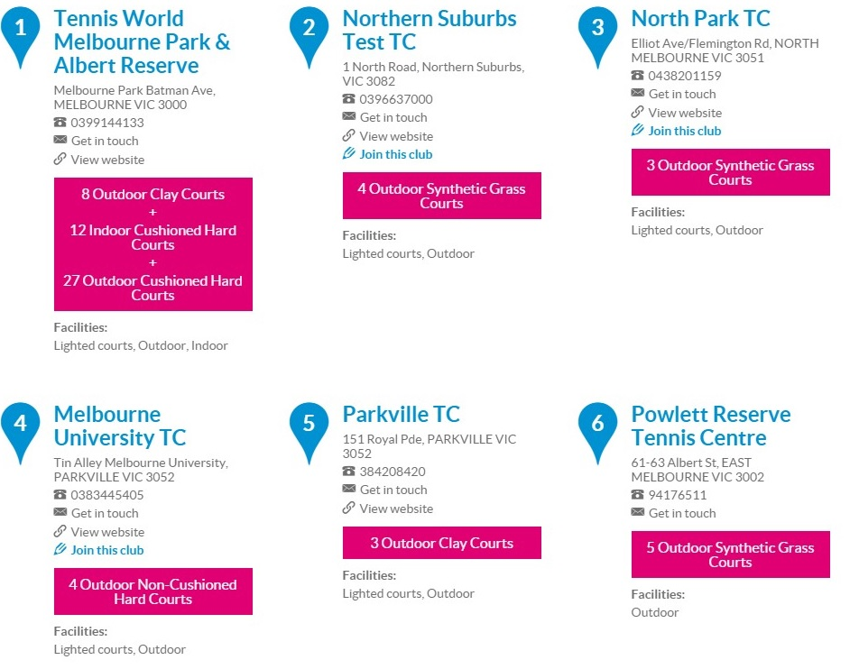
- Select the type of membership you wish to purchase and click the NEXT button that will appear in the bottom right hand corner of the screen.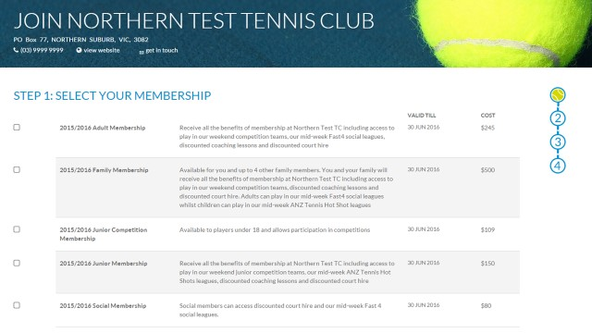
- Please choose the relevant Senior Membership for 2021/22. Choose either Senior or Senior (Student) - both are listed as early bird discount rate which must be paid by 23rd October. If you are paying after the 23rd of October please still select one of these options, but please note additional $30 will apply accordingly.
Please remember to tick the comp and division you would like to play in ( eg Div 2 Mens). Click Confirm
- The system sends you an invoice with payment details.
- PLEASE NOTE THE CLUB PREFERS EFT AS THE PAYMENT METHOD.

